

Course Title: CN Lab
Course Code:CIS 211 L
Lab Task-2
Fall 2025

Submitted by | Submitted to
Md.Nahidur Rahman Khan Nishat  ID: 242-16-061  Batch: 20(B) Lab:20(C)  Department of CIS | Mr.Abdullah Al Mahmud  Lecturer  Department of CIS

Due Date: 25-11-2025 Submission Date: 25-11-2025

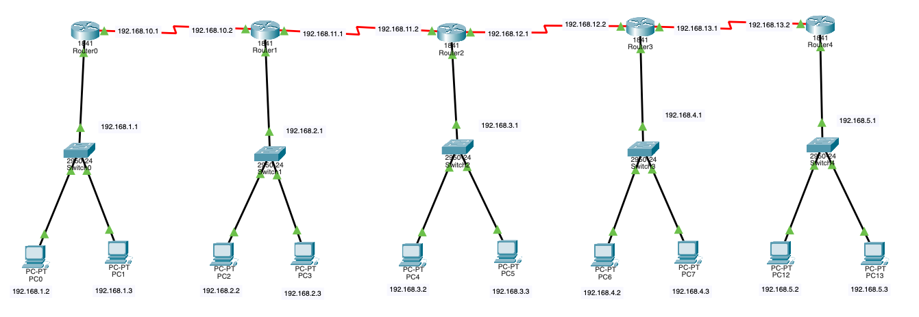
The network has 5 routers, 5 switches, and 10 PCs, connected so all PCs can communicate, with routers using RIP Version 1.
Router and Switch Configuration using CLI command
Router 1
en
conf t
int fa0/0
ip address 192.168.1.1 255.255.255.0
no shut
exit
Router 2
en
conf t
int fa0/0
ip address 192.168.2.1 255.255.255.0
no shut
exit
Router 3
en
conf t
int fa0/0
ip address 192.168.3.1 255.255.255.0
no shut
exit
Router 4
en
conf t
int fa0/0
ip address 192.168.4.1 255.255.255.0
no shut
exit
Router 5
en
conf t
int fa0/0
ip address 192.168.5.1 255.255.255.0
no shut
exit

Router to Router Serial Interface Configuration using CLI command
Router 1
int s0/1/0
ip address 192.168.10.1 255.255.255.0
no shut
exit
Router 2
int s0/1/0
ip address 192.168.10.2 255.255.255.0
no shut
exit
Router 2
int s0/1/1
ip address 192.168.11.1 255.255.255.0
no shut
exit
Router 3
int s0/1/0
ip address 192.168.11.2 255.255.255.0
no shut
exit
Router 3
int s0/1/1
ip address 192.168.12.1 255.255.255.0
no shut
exit
Router 4
int s0/1/0
ip address 192.168.12.2 255.255.255.0
no shut
exit
Router 4
int s0/1/1
ip address 192.168.13.1 255.255.255.0
no shut
exit
Router 5
int s0/1/0
ip address 192.168.13.2 255.255.255.0
no shut
exit
RIP Version 1 Configuration for All Routers using CLI command
Router 1
router rip
version 1
network 192.168.1.0
network 192.168.10.0
network 192.168.11.0
network 192.168.12.0
network 192.168.13.0
exit
Router 2
router rip
version 1
network 192.168.2.0
network 192.168.10.0
network 192.168.11.0
network 192.168.12.0
network 192.168.13.0
exit
Router 3
router rip
version 1
network 192.168.3.0
network 192.168.10.0
network 192.168.11.0
network 192.168.12.0
network 192.168.13.0
exit
Router 4
router rip
version 1
network 192.168.4.0
network 192.168.10.0
network 192.168.11.0
network 192.168.12.0
network 192.168.13.0
exit
Router 5
router rip
version 1
network 192.168.5.0
network 192.168.10.0
network 192.168.11.0
network 192.168.12.0
network 192.168.13.0
exit
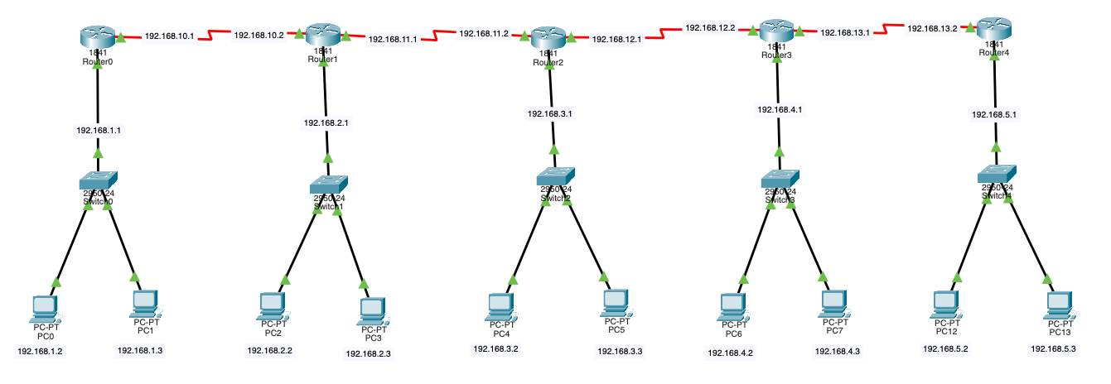
The network has 5 routers, 5 switches, and 10 PCs, connected so all PCs can communicate, with routers using RIP Version 2.
RIP Version 2 Configuration for All Routers using CLI command
Router 1
router rip
version 2
no auto-summary
network 192.168.1.0
network 192.168.10.0
network 192.168.11.0
network 192.168.12.0
network 192.168.13.0
exit
Router 2
router rip
version 2
no auto-summary
network 192.168.2.0
network 192.168.10.0
network 192.168.11.0
network 192.168.12.0
network 192.168.13.0
exit
Router 3
router rip
version 2
no auto-summary
network 192.168.3.0
network 192.168.10.0
network 192.168.11.0
network 192.168.12.0
network 192.168.13.0
exit
Router 4
router rip
version 2
no auto-summary
network 192.168.4.0
network 192.168.10.0
network 192.168.11.0
network 192.168.12.0
network 192.168.13.0
exit
Router 5
router rip
version 2
no auto-summary
network 192.168.5.0
network 192.168.10.0
network 192.168.11.0
network 192.168.12.0
network 192.168.13.0
exit

int fa0/
RIP
RIP: Routing Information Protocol is a way for routers to share information about networks. It helps routers know the best path to send data. RIP is simple and mostly used in small networks.
Differences between RIP Version 1 and Version 2 :
Feature | Version 1 | Version 2
Type | Classful | Classless
Subnet Info | No subnet mask included | Sends subnet mask (supports VLSM)
Updates | Broadcast | Multicast
Security | None | Plain-text or MD5 authentication
Best For | Small, simple networks | Networks with subnets or security needs

